**Diary No.**

**TITLE**: Monitor and reduce Energy Consumption using IoT

**INTRODUCTION:** There is an increasing interest in using IoT devices for making buildings smarter and efficient. For instance, a significant amount of energy is being consumed by buildings. The need for energy efficiency in buildings is critical, and one of the objectives of a “smart building” is to monitor, reduce and manage building energy consumption without compromising the occupant comfort and operational efficiency. Hence, smart buildings can employ different types of IoT sensors in mechanical systems which make these systems more intelligent. A huge amount of data is generated from the embedded IoT sensors and their associated controllers mounted within the smart buildings. This IoT enabled smart building data can be extracted, filtered, analyzed and used for smart building analytics. It is clear that there is a growing interest in smart buildings and data management and analytics. However, there is a dire need to identify the challenges as well as the solutions to overcome those challenges in this domain.

The main question is: what are the key challenges, which must be addressed to effectively manage and analyze the big data for IoT enabled smart buildings using the Agile methodology. Agile methods or Agile processes generally promote a disciplined project management process that encourages frequent inspection and adaptation, a leadership philosophy that encourages teamwork, self-organization and accountability, a set of engineering best practices intended to allow for rapid delivery of high-quality software, and a business approach that aligns development with customer needs and company goals. Our current research is focused on developing such framework using a model driven architecture using an agile approach.

**FLOWCHART:**

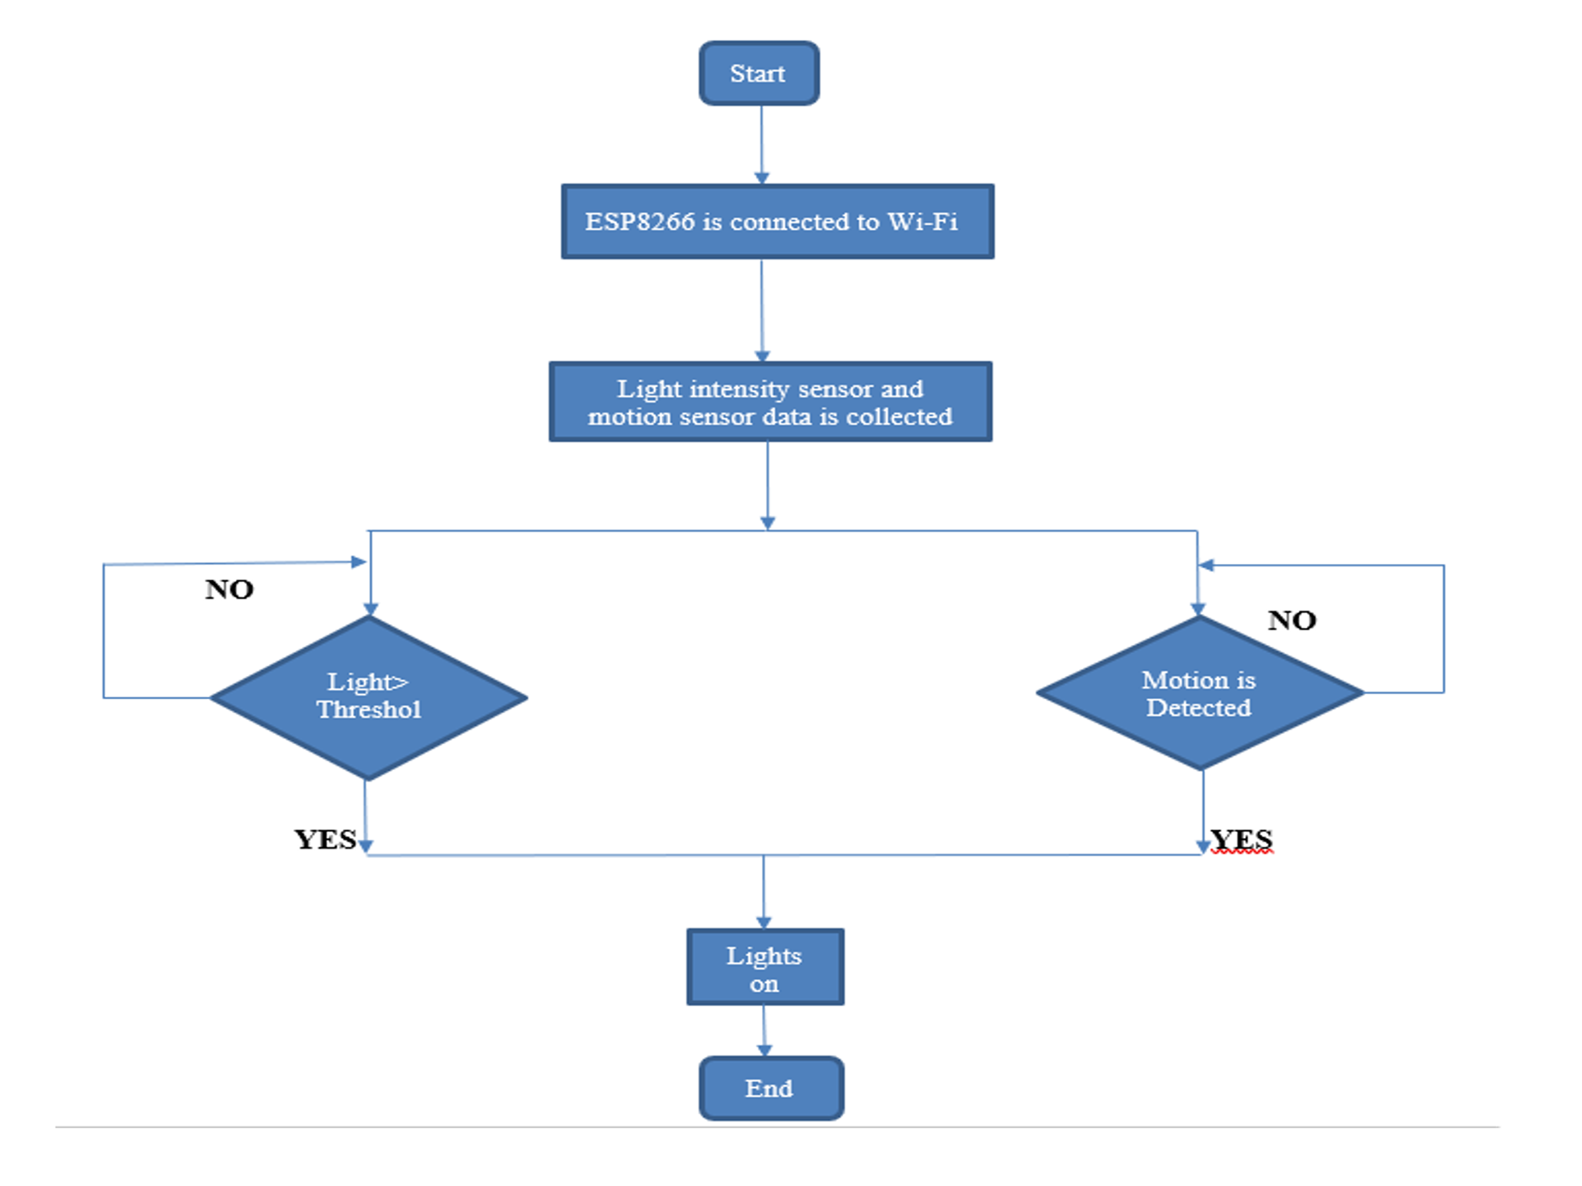

**Fig. 1** Flow chart of proposed system

**Algorithm:**

1. Initialize Node MCU.

2. Initialize PIR sensors.

3. Initialize LDR sensor.

4. Capture motion by sensor.

5. Detect light intensity using LDR.

6. Sensor data is published via Esp8266 using Mqtt protocol over AWS cloud.

7. Node-Red will perform all the logical computations over cloud.

i)if LDR value below threshold value, then turn on lights signal is generated.

ii)if not then let the lights be off signal is generated.

8. Output of Node-Red is sent back to the subscribed NodeMCU as well as over database.

9. NodeMCU will convey the signal to connected relays which will trigger appliances.

10.Graphical representation will be depicted using database over GUI panel.

**CONCLUSION:**

* The goal of this project is to systematically review IoT enabled services in smart buildings. The conducted project shows that this is relatively recent research area, and, judging by the growing number of IOT applications, it is currently in its hype phase.
* The real application of IoT in smart buildings services is still in its infancy phase, even in the buildings which are leaders in this area. However, the IoT potential has been recognized, and it is not hard to imagine the services reviewed in this paper to become normal in a near future.
* Integration frameworks for IoT and related technologies, Interoperability between various kinds of devices and middleware systems in the smart buildings environment.

**APPLICATION:**

1. Can be used in places like household, institutions, industries.
2. Smart Parking, Lighting and Infrastructure.
3. Promotes Green buildings.
4. Energy conservation.

**Applicants:**

|  |  |  |
| --- | --- | --- |
| **Sr. No** | **Name of Applicants** | **Address** |
| 1 | Tejveer Anand | Water’s edge, E2 wing flat no 403, Vishal nagar, pimple nilakh pune-411027 |
| 2 | Siddhant Jain | A-304 Ganesh Shrusti, behind Dmart, Ravet, pradhikaran, pune-412101 |
| 3 | Sourabh Upare | Plot no 10, Jijamata nagar, kumtha Naka, Solapur-413003 |
| 4 | Maithili Andhare | T-5 Nandanvan Society, Vishal nagar, pimple nilakh, pune-411027 |